EXERCISE NO:10

DATE:20/11/2020

AIM:

To Write a Python function that accepts a string and calculate the number of upper case letters and lower case letters .

PROGRAM:

def string_test(s):

d={"UPPER_CASE":0,"LOWER_CASE":0}

for c in s:

if c.isupper():

d["UPPER_CASE"]+=1

elif c.islower():

d["LOWER_CASE"]+=1

else:

pass

print("No. of Upper case characters:",d["UPPER_CASE"])

print("No. of Lower case characters:",d["LOWER_CASE"])

s=input()

string_test(s)

LINK:

<http://103.53.53.18/mod/vpl/forms/edit.php?id=325&userid=1678>

OUTPUT:

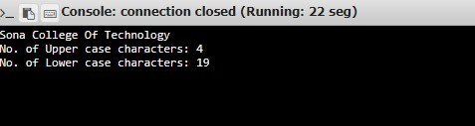

RESULT:

Hence , the Python function that accepts a string and calculate the number of upper case letters and lower case letters is printed.